Our Student Teacher

**January 9, 2014**

The purpose of this practicum experience is to help me develop, as a pre-service educator, my teacher essence and personal philosophy of education. I hope to strengthen the skills I possess and learn many new things from the students, teachers, and people in the Connect community. Mrs. Kelly will be my mentor in this process as we share the role of teaching. My goal is to use her support and knowledge to teach confidently on my own before the twelve weeks is up!

The past semester has prepared me in becoming familiar with the grade four Alberta Program of Studies, and developing a mindset for inquiry learning. I have met with Mrs. Kelly on December 9th so that we can make the transition of my arrival this month as smooth as possible for the students.

Thank you for your attention and allowing me join your kids on this special journey!

Kind regards,

Ms. Glinsbockel

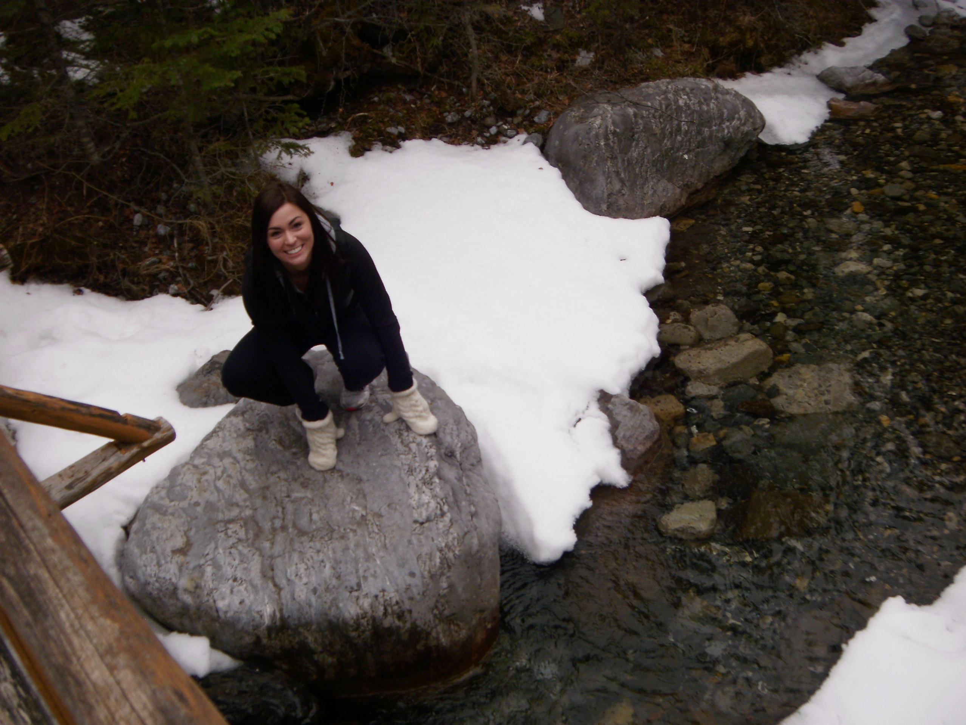

Dear grade four families,

I’m excited to introduce myself as your classroom’s student teacher candidate from Mount Royal University. My name is Brittney Glinsbockel and I have joined Mrs. Kelly on January 8th to begin my second practicum experience of twelve weeks total.

I look forward to getting to know you, but until then I’d like to share a little bit about myself!

Upon my graduation from Vernon Secondary in BC, I moved to Calgary to pursue my dream of becoming an elementary school teacher at Mount Royal University. I’m currently in my fourth year of the Bachelor of Elementary Education program with a minor in Teaching English as a Second Language. I have a growing passion for young people and believe that they are an important part of our future.